1. Abstract 3

2. Introduction 3

3. Background 5

3.1. Business Model 5

3.1.1. Game là gì ? Streaming là gì ? Các nền tảng streaming phổ biến(Youtube, Facebook, Twitch) 5

3.1.2. Game monetization models 5

3.1.2.1. Game-for-sale 6

3.1.2.2. Advertisements 6

3.1.2.3. In-app purchase 6

3.1.3. Streaming Platform Business Model (e.g Twitch) 7

3.1.3.1. Hoa hồng từ lượt donate của người xem 7

3.1.3.2. Advertisement 8

3.1.3.3. Merchandise Sale 8

3.1.4. Doanh thu của các nền tảng streaming (Lấy dữ liệu từ internet) 9

3.1.5. Kết luận, giới thiệu mô hình mới, kế thừa những mô hình của streaming platform vào trong game system 9

3.2. Technical 10

3.2.1. Client-Server Architecture 10

4. Discussion of Findings 11

4.1. The beneficial impacts of the game platform 11

4.1.1. Advantages for the game publishers and the game developers 11

4.1.1.1. Customized Ads (Quảng cáo tùy chỉnh, viewers xem quảng cáo trên hệ thống mình, thay vì xem trên nền tảng streaming) 12

4.1.1.2. Donate Commission (Hoa hồng từ donate, các nền tảng streaming kiếm tiền bằng hưởng hoa hồng từ viewers donate cho streamers) 13

4.1.1.3. Tăng tương tác của người chơi với người xem (More streamers and viewers interaction) 14

4.1.1.4. Getting cut from NFT exchange 14

4.1.2. The benefits for the stream’s audiences 15

4.1.2.1. Tiềm năng hưởng những vật phẩm độc nhất dạng NFT(sẽ nói ở phần dưới) (lấy được có thể do donate hoặc dự đoán) 15

4.1.2.2. Bán các vật phẩm NFT trên marketplace để kiếm tiền 16

4.1.2.3. Donate được thưởng bằng tiền tệ trong game (nếu có) 18

4.1.3. The benefits for the streamers 21

4.1.3.1. Boosting Self-Promotion 21

4.1.3.2. Higher commission rate than other streaming platforms 22

4.1.3.3. Tiềm năng hưởng những vật phẩm độc nhất dạng NFT(sẽ nói ở phần dưới) (lợi thế của streaming-integrated platform) (nhà đấu giá) 22

4.1.3.4. Có thể đặt quảng cáo của bản thân, hoặc được hưởng % doanh thu quảng cáo từ Twitch 22

4.1.3.5. More user in this platform because of the privilege below 23

4.2. Stream-integrated Game Platform Architecture & Design 23

4.2.1. Requirement Analysis 25

4.2.2. Design & Architecture 27

4.2.3. Implementation 31

4.3. Existing Obstacles 36

4.3.1. Game có fanbase và viewers base lớn 36

4.3.2. Cần có cơ sở vật chất, tài nguyên, nhân sự (do handle cả business của game lẫn streaming platform) 37

4.3.3. Tại sao các công ty game ko dùng model ? 38

4.4. Proposed Solution 39

4.4.1. Sử dụng nền tảng streaming với mục đích truyền thông cho game, hướng viewers đến platform của mình, như vậy sẽ hưởng toàn bộ điểm mạnh của các nền tảng streaming, nhưng profit lại hướng về nền tảng mình) 39

4.4.2. Nếu game được xây dựng ngay từ đầu (chưa có fanbase), đẩy mạnh truyền thông về điểm mạnh của hệ thống (như là nhiều reward đối với customers ở đây là players and viewers, như ở phần advantage) 39

4.4.3. Nền tảng streaming (e.g. Twitch) có thể sử dụng model này ? 40

5. Xu hướng tương lai 40

5.1. Vật phẩm độc nhất NFT 40

5.1.1. Vật phẩm game dạng NFT, được tặng cho viewers và players/streamers 41

5.1.2. Tạo nên marketplace, làm nên mô hình play-to-earn, nhưng bây h còn là stream-to-earn, watch-to-earn 43

5.2. Áp dụng streaming vào các ứng dụng game hóa (gamification) 46

5.3. Metaverse và ứng dụng của AR/VR 47

6. Conclusion 50

References 51

# 1. Abstract

Players are increasingly enjoying broadcasting their games, which draws in even more viewers. Advertisement is a significant source of money for both streamers (who present their games as content) and game streaming platforms in this aspect. The streaming platforms’ content is fundamentally in the streamed game, so they make money from all the game assets from the products that the game publishers create. This is the main motivation for us to propose a new kind of game platform, where instead of a third party streaming platform for broadcasting the game, the streaming service is integrated to the game platform itself. This method allows the platform to have more control over how the content is broadcasted and also allocate the capital supposed to be of the streaming platform, back to the game owner. Lastly, the study aims to give an insight into the monetization methods of the game application and the streaming service, with the hope to inspire applying those in game related concepts such as gamification and VR/AR games.

# 2. Introduction

In the modern world, playing video games has become an increasingly common recreational activity. Video games bring satisfaction and happiness to people and they have become a way to relieve stress and a method of storytelling, to lead players to the world built by the development team. The amount of businesses and companies publishing and distributing games skyrocketed to fulfill the need for this kind of entertainment.

Additionally, some people even love to spectate others playing video games for various particular reasons. This leads to the emergence of video games streaming services, where media content about games is created and distributed towards the audiences. Many platforms provide streaming services, but the platform that stands out and has shown to be more dominant than others is Twitch.tv (Farrington et al, 2015), which mainly streams video games content. Twitch is a platform that game enthusiasts and game content creators come to exchange, in a form of streaming, where streamers broadcast their gameplay for their audiences to spectate.

The COVID-19 pandemic has promoted the amount of time people spend on their computers, unexpectedly made video games and streaming prosperous areas in the business world. This leads to the game publisher companies and the streaming platform providers co-operate to attract users to their ecosystem, with the purpose of maximizing profits by their respective monetization models.

From the game publishers’ standpoint, they lose revenue because of streaming platforms. The game publishers create and distribute their games as the product; however, streamers use games and all their related elements such as storyline, assets such as arts and sounds to create content in a third party, unrelated platform. While there is no doubt that some games use streaming services as a marketing tool, the fact that content made by game publishers now brings profit to another organization is a major loss.

Therefore, by combining the streaming platforms monetization models to the game system, it helps to create a concept of streaming-integrated game platform, a new monetization model in which the cash flow that would be generated from streaming does not go to its platform providers, but the publisher company itself. The game publishers now will have the new chance to monetize their own assets the same way that streaming platforms run their businesses. Furthermore, joining both the system also rewards the audiences of those games and the streamers, where they will get gifts related to the game they are a fan of.

Under the global pandemic, this advancing-technology era experienced the trend of Blockchain-related technology, noticeably the Non-fungible token (NFT), which revolutionized digital assets like in-game items as they can be made unique. Chohan (2021) states that many people are interested in NFT in their ability to create the scarcity of digital objects. The emergence of NFT also introduces new enormous benefits for both players and viewers, which the separated streaming platform cannot provide. While the proposed system has its own benefits, the NFT is the pushing factor, and it completes the idea of this combined system. Additionally, the financial elements of this blockchain application also create new methods of monetization, nominating play-to-earn, and more of that, watch to earn.

Our study aims to propose a new platform, which is also a new way of monetization for game publishers. The listed benefits for publishers and consumers are analyzed by assumption of integrating streaming to games, and can be used to conclude the advantages of the platform. The application of the non-fungible token to the system is also mentioned and expected to attract more value to the platform. The study prospects the upcoming trend by observing the current movement of technology, and predicts its impact to this idea.

This thesis discusses the features of this new game-monetization model, its relation to the NFT, its merit on generating additional revenue, and its future trends. Respectively, the thesis consists of analyzing and synthesizing the reason for choosing the platform, the existence of obstacles, the demonstration and example of a model system and assumptions of its trend in the future.

# 3. Background

## 3.1. Business Model

### 3.1.1. Game là gì ? Streaming là gì ? Các nền tảng streaming phổ biến(Youtube, Facebook, Twitch)

Video game is a digital game interacted by using GUI (Graphical User Interface) or Input Device to generate responses from Output (commonly computer screen). Video games traditionally start from console games, arcane games, but continue to rise in popularity in computer games, and handheld devices’ games recently. Video games become hobbies and people love to share with each other,

Video games streaming is a type of streaming where the content to be broadcast is mainly gaming-related. People choose to watch players’ streams to enjoy the company with them, and feel the connection with their particular community. Streamers are also prone to explain their styles of playing video games, give advice to others (Kaytone et al, 2012) which can make the audiences understand more about their favorite games.

Some popular platforms can be listed as Twitch.tv, Youtube, Facebook.

### 3.1.2. Game monetization models

Video games give the players entertainment, expressed as multiple complex emotions. For example, some genres of game elaborate the feeling of joy and fun, or triumphs. People play games to enjoy the moments; the demand for playing games arises accordingly. Therefore, from the beginning of the video game industry, some businesses used games as their primary source of income and they had established monetization models to generate revenue from their users. The three main monetization models are game-for-sale, advertisement and in-app purchase.

#### 3.1.2.1. Game-for-sale

Video games are a kind of product and can be purchased. Game-for-sale can be explained simply as selling video games from retail stores traditionally, but now prefer to be digitally distributed. Following that, instead of buying a physical copy of a video game from the store, players now can download their digital counterparts on the internet. Furthermore, the devices used to play video games, both handhelds and desktop computers, are globally connected regardless of geographical length, making downloading games online more convenient. Another beneficial point is that digital distribution markets players all over the world, not limited to the frequent customers in traditional retail stores.

#### 3.1.2.2. Advertisements

In contrast to paid products, some game publishers will advertise as their main source of revenue, focusing on the common customer-segment, who want to play games without fee. Advertisement can be from a third party company, who sponsors the game to put their ads on, or from the game company itself. In general, there are various types of ads in video games, including noticeably banner ads and interstitial ads. The banner ads might be placed in the edge of the screen whereas interstitial ads stay in the pauses of the game, that has the purpose of minimal user disruption. In general, the advertisement monetization model is used on hyper-casual games, containing elements of repetitive gameplay to try having players stay in their platform. Consequently, the more time players spend on the game, the more time advertisements will be exposed to them, and the more money publishers will make. Although advertisements can be controversial as some dislike its annoying characteristics, many game studios made a fortune from this model, mainly because of the free-to-play nature and additive gameplay.

#### 3.1.2.3. In-app purchase

While free-to-play games generate revenue by advertisements, it does not scale as much as expected. There is no doubt that some games made a fortune by using ads services, it is much less for the larger proportion. In fact, more stable income of game publishers is in-app purchase or microtransaction. In general, in-app purchases are related to players buying items in game; the games remain free, but players can spend their money to get ingame resources and currencies. Additionally, it is even more beneficial because unlike advertisements that depend on ads services, in-app purchases have no limit on the creativity of game developers. They could come up with literally anything, as long as they sell, they are considered financial success. For example, the items could be the game influence such as boosting stat or gaining skills and for some kinds of games, the items even provide convenience like automatically handling some tasks of the players. On the contrary, there are items that do not impact the game, such as character cosmetics or decorators. Those items are widely sold in the heavy skill games, where players do not want to get lost by not paying for items. In conclusion, the potential for making sales of microtransactions is endless and each game can use its unique mechanism to take advantage of it.

### 3.1.3. Streaming Platform Business Model (e.g Twitch)

Video game streaming (or video game live streaming) is an act of showing other people (audiences) what the players (streamers) are playing. Streaming often takes place in some streaming platforms. It became popular because of people's need of sharing hobbies and the need for community connection. In addition, because of the COVID 19 pandemic, it even became a normal activity since people spend more time at home and on their computers, they feel the need to connect and share hobbies online. Streaming is a broad topic; therefore, the purpose of this thesis is to focus on video game streaming only and this thesis will mainly use Twitch.tv as the example of a streaming platform since its business model targets video streaming more in comparison to others.

#### 3.1.3.1. Hoa hồng từ lượt donate của người xem

Most straightforward method for streamers to generate income is through donations from their audiences and streaming platforms make sure that one way or another, they will get part of it. Naturally, the streaming platforms will get commissions for the money the streamers got; however, some platforms have clever ways to make the monetization procedure more interactive and immerse. As a consequence, audiences, although give part of their money to the platform, do not feel obligated to it. For example, Twitch.tv introduces a kind of currency named Twitch Bit, resembling how in-game currency works, but here called in-stream currency. Following that, the users of this platform can use it to purchase items, such as custom emoji that normal users do not have that privilege, but more importantly, they use Twitch Bit to donate to streamers. To further elaborate, Twitch Bit can be an alternative option, in which the platform will get some commission from it since users purchase it with their own money. Additionally, Twitch even provides some convenient ways to get its Bit, such as watching ads, in order to draw their users in their immerse service. The other method which is frequently used is the subscription model. Audiences can subscribe to some certified channels, and just like subscribing to the newspaper office, they pay for their channel monthly to show their support.

#### 3.1.3.2. Advertisement

Similar to its game monetization model’s counterpart, streaming platforms also utilize advertisements to profit their own shareholders. In general, there are two methods to place ads. Firstly, the streaming platforms can place advertisements of their contracted entity to the some particular layouts of their platforms, or they embed to the streamers’ media content, to make the audiences view the ads concurrently with the stream. For example, Youtube places ads to the side of their layout, and they even put it on the bottom side of their channels’ videos. Youtube does this style of ads placing to ensure good user experience, although it is deemed controversial. There are multiple ways to implement this method, either way, the main point is that they require less interaction from the streamers themselves. Another method relates to the sponsor of the streamers. The streamers will get paid by directly stating that their content is sponsored by some agency.

#### 3.1.3.3. Merchandise Sale

There is a monetization model that many streamers use, which is merchandise sales. Specifically, they create products such as shirts or cups with their own design or their brand. These products can be labeled as Merch. In the market, there are platforms allowing users to design their own shirts, the production and transports will be bootstrapped to make the procedure more convenient. As a result, with just some works, the streamers' channels can sell their Merch, since those fans will purchase them to show their support to the channels. Reasonably, the more audiences the channel has, the more sales of merchandise it will make. After that, the streaming platforms can execute multiple ways to get a percentage in the income, and commonly they can provide the supported merchandise platform themselves.

### 3.1.4. Doanh thu của các nền tảng streaming (Lấy dữ liệu từ internet)

Although Youtube and Facebook are the leading forces in the streaming industry, they are more like social media using streaming as a part of their business model. Twitch, on the other hand, was founded with the purpose of streaming itself and video game streaming unexpectedly went worldwide. Therefore, this section will mainly use Twitch as the example, since it reflects most clearly the income of streaming platforms. With over 2.84 millions concurrent users, Twitch is estimated to generate over 2.3 billion dollars in revenue (Iqbal, 2022). In addition, their users are also valuable assets to Twitch, since Twitch broadcasts their advertisement of their contracted third-party, to its users. Despite how good their service is for their customers, it is no doubt that a large number of them go to Twitch to watch and support their favorite streamers, which Twitch might sign an exclusively-streaming contract, not allowing them to stream on other platforms. Iqbal (2022) has collected data from multiple sources such as *Superdata* and *The Information* to show that Twitch continued to prosper in recent years, and he even states that Twitch witnessed a “huge growth” in the pandemic era. It makes sense since the pandemic forces people to stay at home, and they inevitably interact more with the entertainment from the internet, making Twitch more money. In his article, Max Miceli (2021) reported about the leak of Twitch payouts data. He states that the leaked data only constitute of subscriptions, bit donations, and advertisement revenue. It is noticeable that from the two years span from 2019 to 2021, the top streamers of the platform generated total approximately $10 million dollar each, which showing proportionally how much money Twitch can make.

### 3.1.5. Kết luận, giới thiệu mô hình mới, kế thừa những mô hình của streaming platform vào trong game system

The above sections introduce the overview of monetization models of both game systems and streaming platforms. This leads to a motivation for us to come up with a new monetization model , which is the combination of both seperated systems. It can be observed that game streaming platforms mainly use game publishers' products as their content, making them billions of dollars. Alternatively, game publishers can integrate the business model of those streaming platforms to themselves, making the cash flow come back to them, which can be called the streaming-platform integrated game system. In this system, instead of players broadcasting their games on the streaming platform, and viewers watching on the streaming platform, they can do it in the same system that the players play on it. Consequently, the cash flow, originally going through streaming platforms, comes back to the game publishers, because the game they provide, also has the streaming service. The share of cash belonging to streaming platforms, will profit the other entities, including the game publishers, the players and the viewers.

Essentially, the streaming-integrated game platform is just the game system but even including streaming elements. Therefore, the data flow from the game to the streaming service will be more continuous than the discrete of the separated services. Briefly, all the common elements will be reused and because the systems are integrated, the strong advantage is that less data will be transferred compared to third party streaming services.

## 3.2. Technical

### 3.2.1. Client-Server Architecture

One of the most widely used architectures is client-server architecture. Its advantages are reasons to be selected as an implementation method for the streaming-integrated game platform. Client-server architecture focuses on setting up two or more applications, the clients and the servers, to divide and distribute the logic. In addition, the servers are also responsible for handling databases, so everytime the clients request data to be displayed, the servers do the jobs. Client-server architecture is the valid solution for dealing with distributed systems, since the clients can access the servers globally, to reduce the latency.

Client communication protocol can be achieved using client-server architecture. Originally, in the early days, clients were connected through the local area network (LAN), but it raises a critical problem that the locations of those clients must be near. However, with the separated servers to handle communication protocol, clients can communicate with each other no matter the geological distances. Another approach that is widely used even today is peer-to-peer architecture. This will be simply explained as instead of a centralized server, clients will handle both as clients and servers. One client will act as a server (host), allowing others to communicate with. In fact, this method has advantages that configuring dedicated servers is not necessary, and the cost is not as expensive as maintaining servers. However, in the requirement of game development, peer-to-peer architecture is not favored, because it gives the host powerful advantages of lag-free and low latency. All clients have to send a request to the host client, and wait for its response; therefore, it will be unfair for other players since the host is more powerful. Other clients also have a responding time, and depending on the distance between them and the host client, it can be considerate.

[Client-server architecture in the streaming platform]

# 4. Discussion of Findings

## 4.1. The beneficial impacts of the game platform

As mentioned above, the streaming-integrated game platform takes the profit share from the streaming platforms to the game publishers itself, making them and other entities in this business relationship including streamers (players in the game publishers' perspective) and viewers more profitable.

### 4.1.1. Advantages for the game publishers and the game developers

*//do mình có nền tảng steaming chỉ dành cho game trên nền tảng mình, có thể nhận được hết profit mà nền tảng streaming từng được hưởng*

In the market today, after a game is published, some of the players will broadcast their stream of the game globally. The game publishers and the game developers are only paid primarily by those monetizations above, but not those of streaming platforms. However, the proposed new model solves this issue and brings the owner of the game more money. Specifically, not only does the cash flow not go to the streaming platforms, but by customizing the streaming service, the game publishers also have more freedom to build their ideal game system.

#### 4.1.1.1. Customized Ads (Quảng cáo tùy chỉnh, viewers xem quảng cáo trên hệ thống mình, thay vì xem trên nền tảng streaming)

Both game systems and streaming platforms can utilize advertisements to make money; therefore, the streaming-integrated game platform also inherits that attribute. As a result, game publishers can sell ads sponsored by third-party in their own game system, not related to the streaming platform. For top games having the largest fan base, letting streaming platforms make content using their own game system is a loss in revenue, and by integrating the streaming service of their own, viewers can watch advertisements in the game system instead of the streaming platforms. This is one of the methods to redirect the cash flow, supposedly going to the streaming platforms, back to the owner of the game.

Advertisement is a complex activity that requires a great deal of analysis and planning. Game systems display advertisements on the side-layout or the edge of the screen to avoid negative user experience, whereas the streaming platforms illustrate a more improved method, which is advertisement as sponsor. However, both of the traditional ways still have their critical weak point, as the users are still aware that they are watching ads.

The next advertisement model strives to be immersive, meaning they are part of the game’s ecosystem. Users will not be irritated when they get interrupted by ads, instead they watch ads naturally as they are enjoying the game. League of Legends, one of the most popular games in the world, has introduced a new feature called “Summoner’s Rift Arena Banners” (Casciato, 2020) and it is special because it is only visible for the spectators and do not affect the professional players or the gameplay (Casciato, 2020).

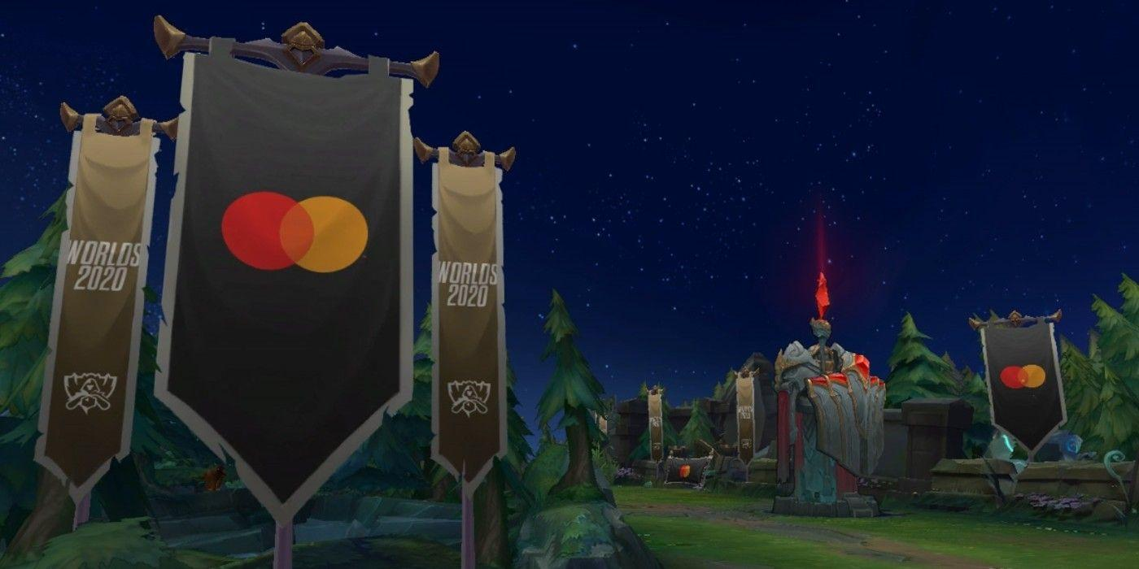

*Advertisement immersively embedded into the game like a decorator*

Briefly, this feature will place a brand of the sponsor on the flag inside the game, but interestingly, only spectators are allowed to see it, not affecting the players’ experience. This will lay the foundation of an exclusive method to advertising, since it integrates advertisement to the game, making it seamless for users. Another point of this method, mentioned above, is that the advertisement looks like game elements, and users do not even notice its existence. Therefore, their irritation of being exposed to ads is not detrimental as traditional advertising, additionally, the players’ experience is accepted although ads are sold.

Even though the new way for advertisement can be added by the current game system, as the streaming-integrated game platform, it has both the game and the streaming technical mechanism, but displays ads not in a discrete way. Specifically, because the system has both game elements and streaming service, the advertisement can be customized for players (streamers) and viewers. For example, there are some advertisements targeting viewers only, and the streamers will not get any ads to improve their user experience. Additionally, immersive advertisements, such as the League of Legends ‘s example above, depend on the game design and monetization model of each business, and in this case, the streaming service model; therefore, each system has their own methods to implement. This section only explains the idea generally, and as long as the implemented methods are profitable, they are considered a success model.

[*insert the example from the demo*]

#### 4.1.1.2. Donate Commission (Hoa hồng từ donate, các nền tảng streaming kiếm tiền bằng hưởng hoa hồng từ viewers donate cho streamers)

One of the most common ways streamers use to generate income through streaming is donation from viewers. Whenever viewers want to support their favorite channels, they will pay money for them as donations, and as can be expected, through one way or another, the streaming platforms will take parts of that revenue themselves. For instance, as has been mentioned above, Twitch uses their exclusive currency called Twitch Bit, allowing viewers to donate using that, and Twitch Bit will be converted to dollars when it comes to the streamers. Correspondingly, Twitch Bit can be purchased with real money, so in other words, to donate to the ideal channels, viewers have to go through Twitch, and Twitch will get their part from it.

On the other hand, if the game publishers set up the streaming service themselves, the whole profit Twitch can make from the content created from the game, will be back to the game publishers. The viewers could then support their favorite channels and also play the game on the same system. Interestingly, similar to some streaming services, the system can generate income from donation itself by taking their cut from fan donation. However, the donation commission percentage depends on various factors, noticeably the business model and the unique feature of the system. The streaming-integrated model does not only have the income stream from the donation, so the game operator can adjust the commission rate to attract more streamers.

*[insert the idea of demo, to show that we just need to implement streaming business model, viewers behavior to watch live, like donating]*

#### 4.1.1.3. Tăng tương tác của người chơi với người xem (More streamers and viewers interaction)

Another beneficial point of the streaming-integrated game platform is the improvement of the interaction between the players and the viewers and the players' retention. Traditionally, the interaction between users are only from the players, but now with the presence of the audiences, players will feel more connected. The way streamers and the audience interact with each other make a business model for popular streaming platforms, so it will lead to more revenue streams for the game publishers themselves. In addition, by organizing events for the audiences getting rewarded, the content of the stream will be more engaging. For example, a prediction event could be set up, which rewards the audience for their correct guess. More interaction means more user retention for the content, which leads to more revenue in advertising and happy users tend to donate streamers. If the platform has more features to compete with other streaming services, more users will join after they know the benefits, and streamers love large numbers of users since they have more chance of getting donated.

#### 4.1.1.4. Getting cut from NFT exchange

The NFT technology is the push factor helping the streaming-integrated game system reach its potential, one of the reasons for that is the NFT marketplace. In the marketplace for game items, users can exchange their own NFT items to get cryptocurrency or vice versa. The game publishers, then, can take their cut from the transaction, so no matter how high the price will get, the game publishers will get profits from it. In theory, whenever the ownership of that item is changed, the game publishers will have their cut. Unlike the traditional games, the marketplace for the streaming-integrated game system contains both NFT items for game and for streaming service, so the users will have more items to trade and the more items the system has, the more money the game publisher can theoretically make.

### 4.1.2. The benefits for the stream’s audiences

Viewers, as one of the entities profiting from the redirection of the cash flow, have multiple benefits when deciding to watch streamers on the streaming-integrated game platform. Furthermore, they are directly benefiting from the NFT integration to the system, generating more value with this trend.

#### 4.1.2.1. Tiềm năng hưởng những vật phẩm độc nhất dạng NFT(sẽ nói ở phần dưới) (lấy được có thể do donate hoặc dự đoán)

Non-fungible token (NFT) is the brand new field in this industry. NFT is the product of the blockchain technology, potentially creating a unique token, labeled as the digital asset. The game industry applies NFT for in-game items, their uniqueness revolutionizing how game items work. Traditionally, each game item binds to its users and its data are stored in the database; however, the application of NFT attaches an unique token for each item, making the users own one-of-a-kind items.

Viewers of this platform will be rewarded with the NFT items. Generally, depending on the game market works and how the viewers are rewarded, it will define which approach the game publishers would use, to maximize their profit, but also not irritate their viewers. This section, therefore, will use League of Legends, as the example of how viewers experience the streaming-integrated game platform. The proposed method is being rewarded by prediction. The viewers, when watching the stream, can make their prediction, with high probability as guessing which side won the game (1 over 2), or with low probability as who has the best performance (1 over 10). The probability value will decide the rarity of the reward, for instance, low impact prediction can only result in a small amount of in-game currency, while the most impact one’s are the limited character cosmetic, which cannot be bought from the market.

The more rewarding method is the prize for a random user. At the end of the match for example, the system could randomly choose a lucky user, to give them a prize with the particular rarity. The game operators can initialize this in a crowd channel, such as over 1000 concurrent audiences threshold, to encourage the viewers joining the stream, and based on the number of the audience, they could raise the rarity of the reward. Nevertheless, as the lottery works, with only one prize on the top, the viewers might not get motivated enough, instead, by introducing a hierarchy of prizes. As a result, more viewers will join with the hope that although they might not have the most valuable reward, they can get something in return.

In conclusion, by just spending their time on the platform channel, viewers will have the chance to win valuable prizes. The game operators will most likely execute the above rewarding techniques, to take the share of users from the streaming platforms, and because they profit from the cash flow supposedly not going to them, they will not experience a loss in revenue.

[Both NFT for stream items and NFT for game items]

#### 4.1.2.2. Bán các vật phẩm NFT trên marketplace để kiếm tiền

The fact that viewers gain the NFT form of the game items leads to making profits by trading them on the game marketplace. The viewers can list their NFT items, place a price and if anyone has the demand for the items, they could look for it. The prerequisite of it is solved by the NFT technology, that each item has an unique token, and if they want to cash out the items, the marketplace is for them.

For instance, if by chance, they get a limited game character’s cosmetic, that can not be bought in the game store, they could list it as an item on the marketplace. Following that, if anyone is interested in the item, they can trade with real money. The rarity of the items is also a factor that affects the trade in the marketplace. If the game publisher announces that there is only a fixed amount of that item, that item will get a high price, and the demand of possessing it will skyrocket.

In the article Talking Point: What Could NFTs Mean For Gaming, And Why Are They So Divisive?, Thomas Whitehead (2022) mentioned about that those who possess the items, either by earing or purchasing, will have the option to sell them if there are demands. He also interviewed Ken Barnes to get his opinions about the NFTs. He stated that “ownership and the transferability of content” is the main factor, and NFT will enabled getting actual cash by selling items as the reward for playing the game and those assets could be passed to others that we want to if we do not play the game anymore (Whitehead, 2022).

Another interesting characteristic of a NFT market is that it reflects the collection of rare objects in real life. An item, made for some individuals only, or being rare, is pursued by the collectors, who take pride in possessing it. The limited game character’s cosmetics experience the same phenomenon. The common method in many games is that cosmetics belong to the decoration only, and should not affect the game mechanism itself, but owning an item that only a few exists is the desire for some people.

For example, in the game League of Legends, there is a cosmetic of a game character called Soulstealer Vayne, which is not for sale in the game store. The only method of getting it is to trade 10 Gems - a consumable item being rare itself, and can only be obtained by luck only. As a result, any players who own this cosmetic are being jealous of other people, since they have an item that is as priceless as even money cannot certainly get them this. The consequences is that the game accounts owning those limited items have a very high price in the game accounts trading platforms and those fortunate gamers can consider their account as an asset, since they can cash it out anytime.

[insert the idea that not only the limited one but also the consumable one]

The idea of NFT game items is not restricted to the ones with limited amounts, but it can also be expanded into the consumable items. In game design, consumable items refer to the items that can be consumed, which means they do not exist forever in the players' inventory, but are gone after the players use their purpose. Some examples of them are health potion, energy potion, that after the players use them for health, the items are consumed. In the case of NFT items, their scarcity is always mentioned and the items only do not belong to their current owner when they are sold to someone else, otherwise they are in their owner inventory. Nevertheless, the same mechanism for the consumable items can be implemented for NFT items. Beside trading the items to get their cryptocurrency value, when the players decide to use that consumable item, for example a tokenized health potion, it will be deleted from the players' inventory. However, the underlying mechanism is that the players trade their consumable to the game, not to other players, and the value they get back contains no cryptocurrency value, but only their items game purpose. This will make the players have to make decisions whether to consume that item. The marketplace, therefore will be crowded between the demand for those consumable items, and the supply of those players having abundant amounts.

[insert the idea that the marketplace is secure because it is from the game owner itself, not scared of scam]

The NFT is only the push factor for trading game items, in fact, the purest form of trading game items took back to the game account market. Some people want to buy a game account for various reasons, noticeably that the game account possesses rare game items. For example, in the *League of Legends* account market, the one who has the rare character cosmetic items, especially those items that are not listed in store, will have a higher price than the others. However, this kind of exchange has the high risk of fraud and scam, since purchasing a game account is not permitted by almost any game. In addition, the players, both in the seller and buyer perspective, cannot trust the others completely, because the market is not an official one from the game itself, so it cannot guarantee that the transaction is fraud proof. On the other hand, the marketplace for NFT items in the proposed system is secure because it is initiated by the game developers themselves, when trading items in here, players are not scared of scam. The blockchain technology itself also ensures the transparency of the transactions, which could be elaborated that anyone in the chain is able to see the transaction history, reducing the risk of fraud.

#### 4.1.2.3. Donate được thưởng bằng tiền tệ trong game (nếu có)

Donation is a part of the streamers’ income, and it is mainly from the audiences, who show their support for the channels by donating money. In the normal streaming platforms in the market, they reward the audiences by giving them certain privileges. Specifically, in Twitch, by donating, audiences can leave a message directly for the channel; this message will be streamed instantly, for both other audiences and the streamers to see. Although all the audiences can communicate through a chat box, the streamers might not pay attention to it when playing games. Furthermore, for a crowd channel, the message in the chat box could easily be replaced since there is an enormous amount of messages coming every second. Therefore, when donating, the audiences’ message will be broadcasted not only for the streamers, but also for other audiences to see. If there is a need for communication with the streamers, or simply just for the attention, the audiences should consider the donation.

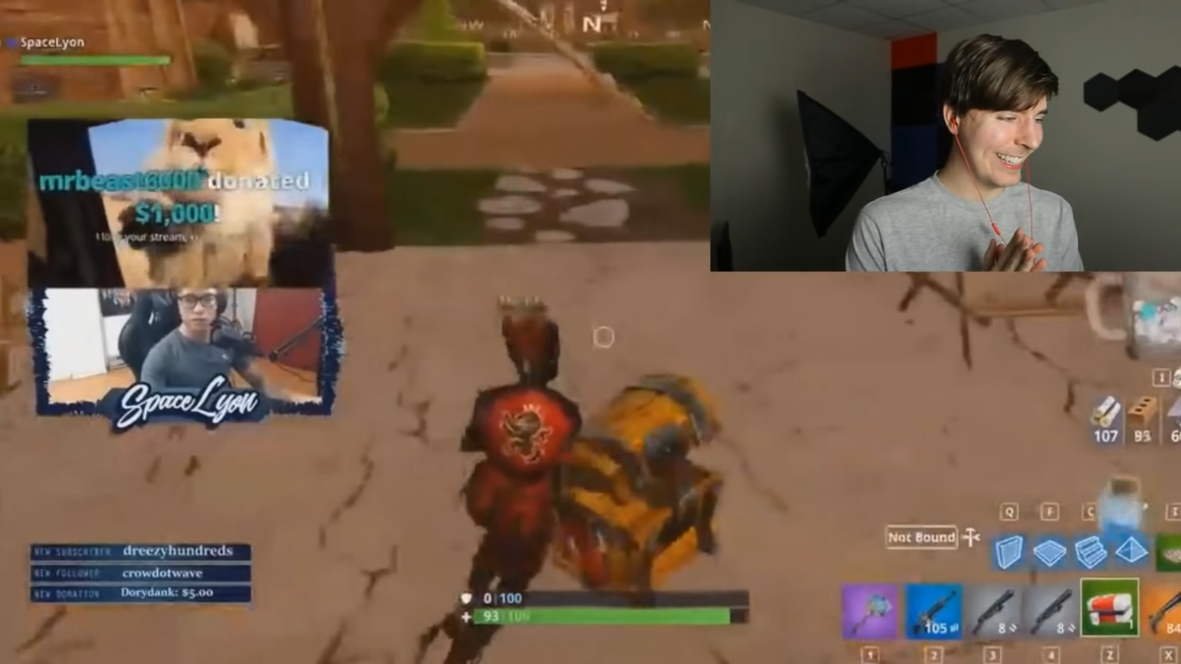

*After getting donated, the streamer get notified*

Beside getting the audiences’ message be broadcasted widely, Twitch also rewards them with the privilege emoji. After donating to the channel, the audiences could receive a special emoji that the normal audiences do not possess. Those audiences can show off those given emoji to others through the channel’s chat box, making them stand out from the crowd.

In the streaming-integrated game platform, the audiences can receive other privileges, as the characteristic of this platform. It handles both the game system and the streaming service, so some of the mechanisms can share the data. For example, the in-stream currency and the in-game currency can be the same, and correspondingly, the store for both the game and the streaming service can integrate with each other. Therefore, the users can purchase both game items and streaming items with one currency.

This nature of the system surprisingly opens many options for the game publishers to choose. The game publishers can reward with the system’s currency for the donation, giving the audiences something in return after they show their support for the channel. The audiences, therefore, can use it to purchase items designed for the streaming service, such as the special emoji. The audiences interested in the game, alternatively, can purchase the in game items. The primary reason for watching the stream is observing someone else playing the game that the audiences love to play, hence getting the reward related to their game enhances the quality of the playing game experience.

The discrete aspect of the game system and the streaming service today do not have the smooth integration compared to the streaming-integrated game platform. First of all, the game system and the streaming service often come from different providers. Therefore, they often have their separated user data, and cannot possibly combine together to reach a high user experience as the proposed platform. There is no doubt that some platforms like Twitch have introduced the SDK/API to help game developers integrate their service to their game, it is still challenging. The reason for this is that both entities belong to different companies, and because of the conflict of interest, it is not easy for both of them to conveniently share their data. Secondly, the streaming-integrated game platform, not only has the same user database, but also has the common store and currency. As the traditional platform, items for streaming cannot be purchased from ingame currency, and vice versa. However, the recommended platform stands out, obtaining the unity in which the users can freely purchase their ideal items, and also have more opportunities to get currency.

<https://www.forbes.com/sites/davidthier/2016/06/28/twitchs-has-an-odd-new-microtransaction-system/?sh=780f03e774e7>

Twitch even had a plan for a new microtransaction called ‘cheers’ (Klepek, 2016), which is the new chat icon that viewers can buy to support their favorite channels. The audiences, therefore, can use in-game currency to purchase those items to support their favorite channels. In the streaming-integrated game platform, there might be some features that can be initialized for a better spot at business competition. First of all, the platform has the strength of a dual system, including more ways to get currency for the users. Therefore, the platform will not force users to pay their real money for those decorating items, but allow the transactions with farmable currency. This makes the users feel more comfortable with their options. Secondly, unlike the third party streaming platform, where the streaming sites have little to no knowledge about the broadcasted game content, the integrated system has full control over what to stream and how the stream is, the game can also reward the fan that donated, make them gain some parts in return. Fundamentally, purchasing Twitch ‘cheers’ is just another form of donating, and while in other platforms the audiences show their support for the channel, the proposed system does not only allow them to do that, but also give them back some value. The reward for donating could be some special kinds of items, used to exchange or build other items. After a certain donating threshold, the game can reward high level rarity items, which some of those might be tokenized using blockchain technology, giving the audience the chance of generating revenue. In the article *Twitch Has An Odd New Microtransaction System*, Dave Their (2016) commented that it is ambiguous about the reason why choosing the ‘cheer’ icon for showing support. However, if the platform reward players with valuable items, which are not out of reach for the game publishers, more users will be willing to try out this method.

### 4.1.3. The benefits for the streamers

As a consequence of that the cash flow goes back to the game owners, the players (streamers) will have exclusive privileges compared to the traditional streaming platforms, since the money share will be used to profit the game’s users.

#### 4.1.3.1. Boosting Self-Promotion

In the article *Watch me playing, I am a professional: a first study on video game live streaming,* Kaytone (2012) discovered that in some streaming platforms like Twitch, the list of Twitch in the main page is sorted by “the highest number of views”. He also mentioned the consequences of this way of listing is that some streams, even a good one, might never be seen by the community. As a result, the streamers have to do all the work to promote themselves, Twitch shows little to no support on that. If the players decide to stream on the game system, they will have the support of the game itself. In the discrete streaming platform, such as Twitch, streamers not only have to compete not just with whom stream with that certain game, but also with streamers of other games. On the other hand, with the streaming-integrated game platform, that issue will be eliminated. The game operators can place the streamers directly on the game system, as the method of advertising them, based on particular categories such as most skilled streamers or most favorite streamers. Streamers with the strength of their skills in game can climb the ladder of recommendation by improving their skills. In addition, they can also advertise them on the game loading page, and depending on the game system itself and the game mechanism, they will discover more methods to achieve this goal. The streamers will be potentially free-promoted, since they do not have to pay anything, and they will now be the asset of the game that makes the money.

In the article *Do Streaming Metrics on Twitch Affect Game Sales?,* Nicholas Sherwin (2019) concluded that it is better for game sales if the game publishers sponsor niche streamers instead of the most popular one. Therefore, if the platform works on its streamers, and categorizes them by certain elements, each streamers can promote the game to their community. Because of that, the streamers are essential for the development of the platform, and will have particular privileges.

#### 4.1.3.2. Higher commission rate than other streaming platforms

Streaming platforms often take some of the revenue from donations to streamers by fans to profit themselves. Since the primary monetization model of the streaming-integrated platform is not just the donation commission, the game operators can adjust the percentage for streamers more competitive than that of streaming platforms. This tactical plan will ensure that players will prioritize streaming directly on the game system, rather than the common streaming platforms. Additionally, not only do they get higher pay, other benefits mentioned in this section will make them consider their decision. The game systems, reasonably, having other game-related monetization to back them up financially, will choose this method as a marketing strategy to gain advantages over their competitors.

#### 4.1.3.3. Tiềm năng hưởng những vật phẩm độc nhất dạng NFT(sẽ nói ở phần dưới) (lợi thế của streaming-integrated platform) (nhà đấu giá)

#### 4.1.3.4. Có thể đặt quảng cáo của bản thân, hoặc được hưởng % doanh thu quảng cáo từ Twitch

Generating income via advertising is still a great option for streamers. They could choose either, place ads of the third-party services contracted with the platform, or choose the advertisement service themselves. With the former option, the streamers get paid with the percentage of the money that the third party services spend on advertising on the streaming platforms. However, the latter allows them having the right to choose any ideal advertisement provider, with the potential of getting higher commission compared with the first option.

#### 4.1.3.5. More user in this platform because of the privilege below

It is clear that beside any provided benefits above, the streamers choose the platform based on how many users that platform has. Therefore, if the streaming-integrated game platforms have a large user base, streamers will decide both playing the game, and streaming it on it. The game publisher might not limit their streamers for streaming on their platform exclusively, allowing them to stream on other platforms too. The streamers, after that, can just pitch about the benefit to other audiences that are not aware of this platform, and lead them to register because of undoubted benefits.

## 4.2. Stream-integrated Game Platform Architecture & Design

*// Để chứng tỏ luận điểm về mặt kỹ thuật có nhiều trên market, tuy nhiên ít ai sử dụng tính năng xem người khác chơi trên platform rồi thêm các tính năng streaming (comment, donate,...)*

This section will discuss the overview of the streaming-integrated game system architecture and design, and it will present a game system as a demonstration. The system is the game called Five In A Row, a well known game which also provides the streaming services. It is worth mentioning that the architecture and design discussed in this section is a theoretical proposal, in real life, different problems require flexibility and the willingness to adapt. In addition, although Five In A Row is chosen to be the demonstration because it has a quite simple logic, it is still possible for it to become the mainstream game having the majority of players. One of the traditional games that has become trendy is Chess. After the Netflix series The Queen Gambit, the interest in Chess skyrocketed. Chess.com, an online Chess game platform, recorded a surge in popularity and the emergence of the new players.

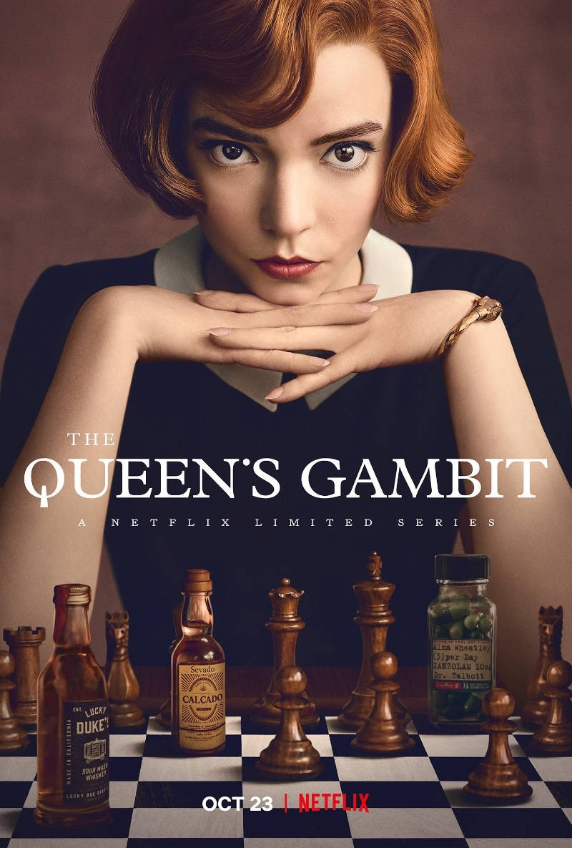

*The Queen’s Gambit Series raised the popularity of Chess*

The article “*How has The Queen’s Gambit impacted the popularity of online chess?“* written by David Zhange (2021) states that the international success Netflix series contributed to the rise of new Chess players and the number of Chess games played in a period of time. The author collected the data from Chess.com API, and then used analysis to show that after the series became popular, so did the platform Chess.com, since people were inspired by the series.

<https://towardsdatascience.com/how-has-the-queens-gambit-impacted-the-popularity-of-online-chess-43594efe5a98>

To conclude, even though Chess.com presents Chess, which is a traditional game, it can still generate a luxurious amount of revenue for its developers, so the feasibility of the Five In A Row game is still ensured if there is an opportunity.

### 4.2.1. Requirement Analysis

This section describes the requirements of the system, including the standard feature of both the game part and the streaming service part, and the non-functional requirements for them will also be mentioned.

[insert the statement that the system must have the game and the streaming]

First and foremost, the system subject is about the streaming-integrated game platform. This means that both streaming and game business must be supported. After that, users could choose between those actions of playing, streaming (playing but also broadcasting), viewing stream without any restrictions or limitations. The users also can switch between playing and viewing with ease and the system must be able to handle different users with different use-cases concurrently, without affecting each other’s experience.

[insert the requirement of tic tac toe game, which is nothing to special, just a normal game, but also talk about the characteristic of the game (strategy game, does not require too much physics or animation) ]

The demo game for the system is the Five In A Row game. This game has a simple and straightforward logic, and also is well known. The rules of “Five In A Row” is two players having their separate piece of chess. Each turn a player places a piece on the grid board, and the winner will be chosen by having five pieces together in either vertical, horizontal, and diagonal position. Briefly, this is a normal game, suited for demonstration purposes. However, a more complex game requires more requirements analysis, noticeably how the rules are implemented. Players also can play online, or offline with the AI.

In addition, this game is a strategy game, in which the factors such as physics, animation and graphics are not significantly necessary, but other genres like MMO, FPS games need more analysis since those factors can affect other parts of the requirements.

[monetization of the game such as microtransaction i.e marketplace, game store, or advertisement services]

Other standard requirements should also be handled like monetization services. The game should have its own microtransaction business model, which means players can purchase game items with their money. Similar to other games in the market, the game should have at least two types of in-game currencies, one for game reward and the other is the value players purchase with their money. (<https://leagueoflegends.fandom.com/wiki/RP>) The marketplace, or game store should also be set up conveniently for purchasing game items. Last but not least, the advertisement services should also be implemented to maximize the profit for the game publishers.

[talk more about the requirement of the streaming service, such as fan chatting or donating]

Twitch has proved to have more users retention than Youtube (Farrington et al, 2015) which can be explained that although Youtube has more users, Twitch users spend more time watching streams on Twitch, so it is more profitable to analyze the requirement from Twitch. The article *ANALYSIS OF THE CHARACTERISTICS AND CONTENT OF TWITCH LIVE STREAMING* also concluded that Twitch presents itself to be an option more gaming-oriented than their counterpart from Youtube.

As a result, the system should provide a good experience for the streaming service, comparable to what Twitch has accomplished. The standard for them is good streaming quality, seamless video moments. The feature of chatting between the channel's fans should also be implemented to encourage engagement. One of the most common ways for streamers to make income is donation from their fans, the system therefore should implement the feature as standard for them to stream. Donation could be implemented directly, like sending cash by transferring, or indirectly. For example, as listed above, Twitch.tv uses Twitch Bit for donation services. The users can purchase those currency with their money, and then if they want to support their favorite channel, they can use Twitch Bit, and the streamers will get fiat instead of Twitch Bit. If the system can initiate this method, it can take the cut from the donation conveniently rather than transferring fiat money. [Facecam streamer]

[talk about the advance feature, such as save the stream to an video file]

Some streaming services including Twitch, Youtube Gaming also have some advanced features to stand out to their competitors. For example, those platforms have the ability to view the stream replay, beside live streaming, viewers can watch the replay of that stream. In addition, Twitch allows their streamers to cut part of the video to create content such as highlights of the match. This feature helps the streamers to put content on other platforms more conveniently, which inadvertently helps them get more fans, and the fans will come for Twitch to enjoy those streamers, making money for Twitch.

[standard non-functional requirement]

The system should also have standard non-functional requirements, including performance, security, reliability and maintainability. Specifically, the game should run smoothly, the risk of lagging should be low, and the game should be able to be accessed 24/7, and any maintenance closing should be scheduled and noticed previously. For security, the password of all users should be hashed and safely stored, and two factor authentication should be an option in the setting menu.

[non-functional requirement for video games]

The standard non-functional requirements for video games state how the game system should work regardless of the game logic. The game should not crash, or the crashing rate should be as low as possible. In addition, the accessibility of users is reliable for all users’ types. Furthermore, The system should have standard non-functional requirements for streaming services. For example, the subscription feature should be implemented and allow users to subscribe or cancel it at any time. The system should be user friendly as providing instruction for first time users, or giving notifications for deleted content, commonly as videos.

[non-functional requirement for streaming service]

### 4.2.2. Design & Architecture

Based on the requirements, the design and architecture can be concluded to satisfy them. There are a lot of ways to design the system, this section only proposes an approach for it. In addition, this section focuses on the higher layer of the architecture, how the detail level of each sub-service module is designed is not the scope. Essentially, the streaming-integrated game platform is just the game platform with streaming elements migrated such as broadcasting gameplay, viewing them, group messaging, and donating.

Streaming-integrated game platform

=

Game

Streaming elements i.e broadcasting, viewing, messaging, donating

+

[share system, fake streaming]

In the current way, the streamers play the game in its application environment, then set up the streaming package. The game will be screen captured, and that content will be broadcasted on the platform. It is noticeable that both the game and the streaming service are loose with each other, presenting little connectivity. However, because the streaming-integrated game platform has both the tight connectivity, it is proposed that rather than screen capturing, the system can apply the streaming elements to their game, to make it look like a live streaming.

Furthermore, sending media data like video data is expensive, while applying streaming elements to the replay mechanism only need scenario data, since all assets that can constitute the gameplay can be loaded from the client through the scenario direction. Under the circumstances that the player is broadcasting their gameplay, which is the action of streaming, the data flow can be represented by this diagram.

Client

Playing

Streaming

Spectating

Broadcasting

The client supports playing, streaming, spectating

Authoritative Server

Player Input Data

Streaming Data

Client

Playing

Streaming

Spectating

Spectating

Server send the result back

Viewing Data

Response Data

Art, Audio, Video

Load Asset

Art, Audio, Video

Load Asset

Database

[insert data flow diagram explanation]

The system mainly consists of clients and an authoritative server. The client has multiple functions of both playing, broadcasting and spectating. When the users choose just playing, their input in the gameplay will be sent to the server and waiting for the confirmation. The server will respond with data commanding the clients how to behave. The client will have all the assets such as art, audio and video on the local machine, the server will give the order on how to serve them to the user, on which the client will follow. This flow of data is standard of the client-server architecture of game development. However, the data flow of the broadcasting mode is worth mentioning. Its behaviors are similar to that of playing, but it allows the spectator to watch the game and interact with it. In traditional streaming set-up, the data to be sent is video data, usually screen capturing data, and when other clients want to watch it, that data will be transmitted and the client will decode and synthesize them to serve the content. Nevertheless, unlike the discrete streaming service and gameplay, those modules of the proposed system are connected, and can use the existing replay mechanism to improve the data transfer model. In the replay mechanism, not only the playing clients receive the data from the server, but the spectating clients as well, and the only difference is that the playing clients can send player input data to the server, but that of spectating can only receive. This mechanism will reduce the latency since the video data is expensive when transmission. It is also obvious that this method does not comprise the initialization state and network disconnect state, in which the server might send all gameplay data to the spectating client to construct the view.

After that, other streaming related features such as donating and fan messages will be added. Instead of sending player input data, the spectating clients will send audiences input data, which the majority is chat messages. The spectating clients will have different chat windows, simulating how the audiences chat. Another audiences' use case to be mentioned is donating. In the spectating client, it will send the data about the donation to the server, where it can use payment service to handle. After the main feature of watching streams is implemented by re-using the replay mechanic, other features of other streaming services can be added just like building blocks.

It is worth noting that the replay mechanism and watching live game have not been new features, in fact, they have been implemented for a while. After that, by implementing streaming-related elements, the live streaming experience can be recreated as similar as broadcasting game content. Therefore, it can be concluded that the design of the system is not new, but the idea of using replay for streaming action is.

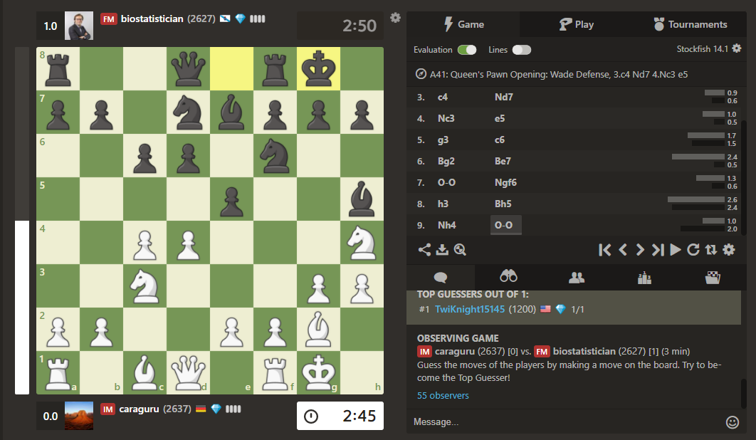

*The feature of watching live game of Chess.com*

[mention that facecam might need to sent as media data]

The design also presents its merit on cross platform systems, both for streaming services and game applications. Specifically, under the assumption that the game can only be played on non-mobile platforms, when watching streams, users could watch on both desktop and mobile devices. When data is responded to the audience clients, the system just needs to be able to process it. Unlike the video streaming services, where the metadata has (expensive latency), all the asset of the game applications is stored locally in the devices’ memory, and will be allocated when orders have been made from the servers. The mobile version of the application could be optimized with lightweight assets. In the desktop version, the power of the devices is sufficient to handle the detailly game assets such as specific game arts, or special effects, but in the mobile counterpart, that power is limited compared to that of desktop. While the data transfer and client-server communication stay the same, the mobile application can use the lightweight version of the game assets, for example low poly 3D art to ensure the quality of the clients.

### 4.2.3. Implementation

The sample implementation of the system will be discussed. For demonstration purposes, a small game application called Five in a Row will be made, supporting users wanting to stream or watch in the same app.

The project follows the client-server model, which means that there is a server controlling the data traffic and how clients communicate with each other. Socket Programming is chosen to handle the communication with the clients and the server. The application is also multithreaded to support multiple operations without blocking each other.

[insert code snippet, ClientHandler]

The server handles each of the clients on separate threads. When a new client connects to the server, a new ClientHandler object is created with the purpose of analyzing the sent and received data. ObjectInputStream and ObjectOutputStream are used because the data communication is represented by a custom object Message in the Message.java class.

[insert code snippet, Message]

Each Message object has an attribute message type, which is the enum class handling the specific behavior of the application. When data is transferred through clients and the server, based on the MessageType, the clients or the server will perform specific operations for the game. The use of Enum class also makes the code more intuitive.

[insert code snippet, MessageType]

The Server package also contains the Room class to create a new Room object. Each Room object stores data about how the game is executed; therefore, all the logic of the game is stored on the server and the clients only send the data for processing.

[insert code snippet, Room]

For the client, the ListerServer object is created in a different thread for handling server communication. Specifically, each request from the clients will go to this object, and for each response of the server through it, the clients execute operations based on the MessageType

The system also supports separated interfaces between the spectating client and the streaming client. For demonstration purposes, the clients can join any room to watch the game, but for the real system, the streaming clients will have the option of broadcasting their game or not. In the streaming client interface, it supports the gameplay, the clients can also message their opponents and their viewers. In terms of spectating, the clients also have the option to donate the streamers and have their own exclusive chat window where only the audiences can send a message.

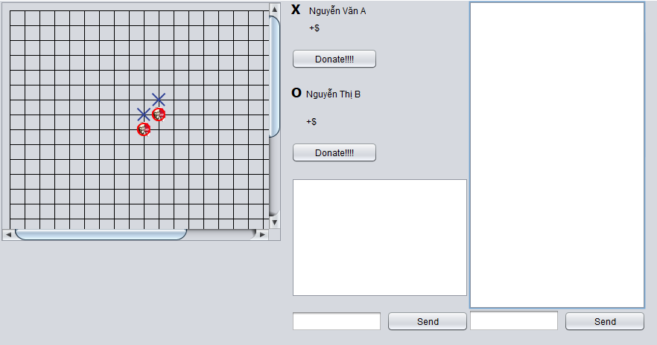

*The client’s interface as the audience*

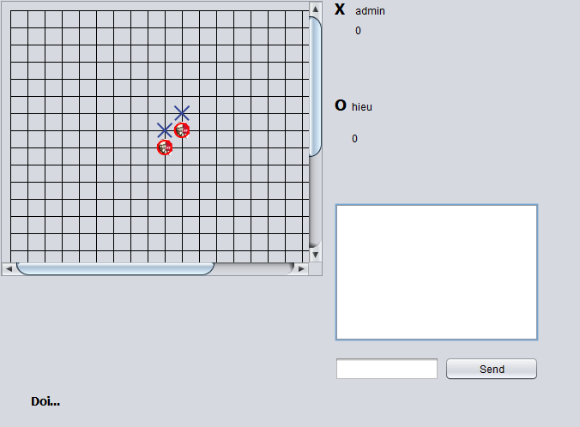

*The client’s interface as player/streamer*

The implementation of the demonstration system follows the principles of loose dependencies. The logic of the system, for both the clients and the server should be separated from the user-interface (the View part). Specifically, after the event of the users interacting with the interface is fired, the interface should redirect to the logic core of the system, and give the output after processing. For the clients, the function for playing the game is separated from the other parts of the system, such as joining rooms, messaging, or viewing other matches. The clients have an object called ListenServer to communicate with the server, and because the application uses Socket Programming, that object is separated from all the client logic, and it handles all the requests and responses from the server. From the server’s perspective, similar to how clients work, an object is dedicated to process the communication. However, the server supports multiple clients concurrently by handling each client in a thread, to ensure no blocked data transfer. The logical parts of the game, such as deciding the winner, and all the data related to the game scene, are managed in a separated Room class, and each time a match is started, a Room object will be initiated to store and handle the necessary data of the game. 

The application follows the principle of multithreaded and server confirmation. Basically, it means every necessary operation will be executed in a different thread to avoid blocking, and every request from the clients will be confirmed by the server for security purposes.

In the server, the initial operation has two runnable threads, one for handling UI and the other for listener. The listener has the task of waiting for client connection, and every time the connection is established, a new ClientHandler object will be initialized and run in another thread. That thread will be a bridge for client and server to communicate. Therefore, every clients’ requests and responses will be processed separately to ensure no block operations.

In the client, when the application starts, the login form is opened. After that, an object called ListenServer is created for routing requests and responses from the server to specific operations of the client. When the users enter the authentication data to the form and send it to the server, a message object has the property of the payload and the message type. In this case, a message has the type standardized as login type, and a body of username and password is sent to the server for authentication. When the authentication is proved, the server sends back a message to let the client know, after that, the windows for starting the application are opened.

After authentication and the communication is made between the server and the clients, each operation is made by sending a message to the server. Furthermore, each object is run in a dedicated thread with no overlap with each other, and those objects also have a reference to the ListenServer object, that responsibles for server communication. The gameplay also follows this principle of client-server communication, for example, each time users want to place a chess, the client will send a message to the server, which informs them that a chess is placed in that position by that specific player. After the server gets that message, it will update the data on the server-side, and then send back a message of agreement, the client is updated accordingly then.

## 4.3. Existing Obstacles

Although the benefits of the model are paramount, it is undeniable that there are still existing obstacles for the company wanting to use it. From the technical view point, the implementation of the model is possible, but is the effort worth it is challenging, and demands further analysis and planning. Furthemore, an overall view is that it is difficult to change people’ behavior, since they already have the habits of accessing other streaming platforms.

[Insert that it difficult to change people habit, behavior]

### 4.3.1. Game có fanbase và viewers base lớn

The game should have a large user base and fanbase, to make the implementation of the model not redundant. On the contrary, the whole business model will not reach its full potential. The user base includes the streamers and the viewers, and although those users are mutually exclusive, the streamers need the audiences to watch. In addition, the system is the combination of both game platforms and the streaming service, if the large proportion of players all focus on playing, there is not enough time for them to watch someone else play. Otherwise, the game should have a large fanbase. There might be a confusion between the term fanbase and the user base, since they sometimes overlapped. The user base is related to the database of the players, while the fanbase is a more broad term. For example, in the game League of Legends, the game designers extend the lore to the universe level, which means they even create more different games, but those also have the same lore. The fanbase, therefore, even includes those who love the game but have little interest in playing it, and they just want to enjoy the story to a certain extent.

[insert the idea that they might need a large fanbase -> How to get it ?]

[insert the idea that if they do not play the game, would they watch Twitch instead ?]

### 4.3.2. Cần có cơ sở vật chất, tài nguyên, nhân sự (do handle cả business của game lẫn streaming platform)

Due to its characteristic, the streaming-integrated game platform requires more resources to be adequately operated. It has been stated that this monetization model is the combination of both the game system and the streaming platform. However, this also presents certain challenges, noticeably the lack of employment. The operators of the platform need to handle both game business and the streaming business. Therefore, the work is costly in terms of training and operating.

The game design and business design also required effort to ensure the quality of the system. If the system rewards players by game items, as mentioned above, the game designers should consider very carefully which items they will reward, and which items can only be acquired by other ways. The consequences of low quality game design can make the game not balance, which potentially leads to the departure of the players. Additionally, the business model design, including monetization models, and budget allocation is complicated due to the combination of both systems. The game publishers, or in other words, system operators should do the research for operation and management of the existing and substantial system to develop the business rules for the system itself.

[game design, business design]

The facility, noticeably the database and the server system, needs to be considered as well. This platform requires an enormous amount of computational prowess to direct and process the data, and depending on the specific situation that the companies are dealing with, they should initiate a suitable system architecture. While business solution applications might share some similarities, each game stands out with others since they embrace the differences. The system architecture, therefore, is demanded of being flexible for the system' s accessibility. The fact that the system is handling both the game app and the streaming site makes more issues to be resolved.

### 4.3.3. Tại sao các công ty game ko dùng model ?

[consumer behavior research, if the user need this, then use it, else, need more planning]

[It is hard to change people habit]

The streaming-integrated model is the suggested model, and that all the game companies are not using this, possibly because they do not discover it. This section only presents a glimpse of some reasons why they might not want to use the model since it is rather new; therefore, more analysis is required to give a better prospect. This model is profitable and beneficial, and the company who has the resources to implement it, will become the pioneer in this industry.

Furthermore, as mentioned above, it all comes to the effort to handle the system, and is it worth it with the current user base. If the player's statistics for watching the game is not significant, designing this complex system might not be the business decision. However, if the game can manage to attract a large number of users, the problem becomes similar to the scalability of other systems. The streaming and the game system will then be worth their investment, as a useful commercial product.

On the other hand, if the game is popular enough, for example, the game stays at the top most viewed on Twitch, there is almost no downside. This section will use the game League of Legends as the reference [insert why LoL works /streaming]. The game has multiple resources, leading to no significant challenge when setting up the streaming handling employers. Furthermore, the game has sufficient facilities such as the network infrastructure, powerful computers for the database and the server. [infrastructure, database or server]

## 4.4. Proposed Solution

The obstacles that the platform faces might be resolved by the suitable solutions.

### 4.4.1. Sử dụng nền tảng streaming với mục đích truyền thông cho game, hướng viewers đến platform của mình, như vậy sẽ hưởng toàn bộ điểm mạnh của các nền tảng streaming, nhưng profit lại hướng về nền tảng mình)

The game company, even though constructs the streaming service of their own, still can use some streaming platforms such as Twitch to their own advantages. The game system applies the monetization models of the streaming platform to generate revenue; however, it can use streaming platforms as the marketing strategy. In today's world, streamers are just like influencers, if they promote a game on their stream, their fans will look for it and try the game out. Therefore, some game teams sponsor streamers to promote their game, but if the game somehow catches the attention of the streamers, they will play it and unexpectedly promote it. If the streaming service is integrated with the game, streamers can stream both on the streaming platform and the game itself. Following that, streamers can promote the game, by asking their fans to watch the stream on the game instead of the streaming platform. In fact, with the remarkable rewards for both streamers and viewers, they will go for it because it is a win-win situation.

### 4.4.2. Nếu game được xây dựng ngay từ đầu (chưa có fanbase), đẩy mạnh truyền thông về điểm mạnh của hệ thống (như là nhiều reward đối với customers ở đây là players and viewers, như ở phần advantage)

The marketing team should use the strength of the system, such as the common market store to attract more users. Usually, in the game product, the marketing team uses the special game mechanism, or the appealing game art to promote it. However, for this platform, they should consider running the campaign for the characteristics of the system. Particularly, one of the key points is the shared market store of both the game and the streaming service, that if the players want to “gold farming” (the term references to the act of getting the in-game currency), they could watch others playing to get it instead of playing themselves. Another strength of the system is that its players (related to both streamers and viewers in the streaming viewpoint) will acquire massive rewards as mentioned above. As the result of gaining the share of cash from other streaming platforms, the system will prioritize its users, to promote the game.

### 4.4.3. Nền tảng streaming (e.g. Twitch) có thể sử dụng model này ?

*// phần này em sẽ nói về việc nền tảng streaming tự tạo game trên hệ thống của mình (bổ sung game thay vì tích hợp streaming trên game)*

The monetization methodology, interestingly, could be applied to the streaming platform itself. While in the game system’s perspective, it integrates how the streaming models work to their own game, with the purpose of inheriting their monetization models, the streaming platforms can do the opposite, which is creating a game of their own. One of the main characteristics of the streaming-integrated game platform is the shared system store, that can be simply explained as both mechanisms share the same store and the same currency. The users, consequently, can purchase game items with the currency they obtain by watching stream or streaming, and alternatively, can purchase streaming-related items with the currency obtained by playing the game. Therefore, the streaming platform can do the opposite as the game product did, that it can implement a gaming system. For example, Twitch already has the microtransaction system, it can just create a game that uses that system. The users, therefore, will have more items to spend their digital currency on, making the crowd an economical atmosphere.

# 5. Xu hướng tương lai

The above sections only discuss the observable and analytical benefits of the streaming-integrated game platform, the full potential of the platform lies in the future. The world experienced the drastic change of the technology trends, and it is interesting to discover which trends will augment the platform, pushing it beyond its market competitors. Because the platform is mainly a game, it inherits all the game elements, and will be supported with all game-related trends.

## 5.1. Vật phẩm độc nhất NFT

Blockchain-based gaming revolutionizes how games are developed and played and GameFi is considerably one of the most trendy topics in the crypto industry. The primary reason for this phenomenon is that blockchain technology can be applied to make non-fungible tokens, or NFT.

### 5.1.1. Vật phẩm game dạng NFT, được tặng cho viewers và players/streamers

If GameFi presents itself as the potential gaming model, the combination of it and the streaming service will definitely extend it further.

In the GameFi economy, players, as the main focus entity, can farm NFT as collectable items by finishing tasks, trading or purchasing them. Therefore, its combined model with streaming, which has streamers and viewers presents certain methods of farming the token. Players can start a streaming channel, to be given the opportunity to farm NFT by the game as additional from playing the game. The conditions for this act depend on multiple factors, such as bypassing a viewers threshold, or subscribers threshold. On the other hand, players can choose to watch the stream and get the NFT for it.

The reward for both of these actions should be considered seriously. The game designers team should come up with the solutions that are best for the game's specific situation. The streamers with positive engagements should be rewarded with the NFT items, so that they can capitalize on them. For viewers, mining the token should be more difficult, since there is almost no cost to watch the stream, but for the streamers, they have to put effort on their channels. As mentioned above, viewers can be rewarded randomly by the game, and the larger the viewers' number is, the more valuable the NFT is, since clearly the probability is higher. In contrast, viewers can be given the prize as the selection of the streamers, to honor the fans who support the channel. The NFT reward should not be one time only, by having multiple prizes for multiple random people, they will get more chances to get them and will be more likely to be interactive with the stream.

In the traditional game, the items exist within the game. Even if its data are stored on the database, the existence of them is in the boundary of the game. Therefore, when players decide not to play that game anymore, they lose their ownership of the items. Their items are still in the database, but outside the game, the players cannot interact with them. However, in the blockchain game, the items are tokenized and belong to the players entirely. Even if the players close their account, they still have their true ownership of those items. This feature is enabled due to the blockchain technology; the items are in the blockchain cloud, which are stored in the players' Ethereum address, and they can just use them for the game. Furthermore, if the items demonstrate their value, players can convert them into cryptocurrency even after they stop playing.

[Idea of the game stream together]

In the streaming-integrated game system that was proposed, there is a wide range of item categories that can be tokenized, providing the ability to convert themselves into cryptocurrency, noticeably the game items and the streaming emoji. The ownership of the users will reach far beyond the current services, since the items were even recognized as the possession of the users in the blockchain cloud. Similar to the aforementioned game items, the tokenized emoji exist outside of the system itself, and will continue to do so even if their owners decide not to use the services. In addition, the users can trade their emoji to get the Ethereum cryptocurrency and the higher the rarity is, the more monetary value the users can get.

Another interesting concept to be discussed is the fact that the items can have dual purpose, one for games and another for streaming. After purchasing those items from a game store or marketplace, the users can use the items as their role demands. For example, a game could introduce an item which is a character cosmetic, allowing the user to decorate their game experience with diverse factors when playing or streaming; however, the item can come along with a use case for streaming, such as an emoji. To be extended, the items are not restricted in both the streaming service and the game system because the items even exist in the blockchain cloud, which means, other games and other streaming services can theoretically use that token in the systems. On the contrary, the proposed system can even use the tokenized items in other games, to make the system more user-oriented. Therefore, the marketplace will have the diversity of listed items, and if the game publishers generate revenue by taking commission of users' microtransactions, they will make profit from it.

[connect with other NFT platform, like take their item to our system, or marketing technique]

[coin staking][item in game to boost stat, but in stream is just emoji]

[idea of use the items for other game, other stream as some kind of multiverse]

### 5.1.2. Tạo nên marketplace, làm nên mô hình play-to-earn, nhưng bây h còn là stream-to-earn, watch-to-earn

* Ví dụ là viewers dự đoán các hành động trong game mà streamers đang chơi, dự đoán càng khó sẽ càng nhận được các vật phẩm hiếm
* Các nhà phát triển game có thể tạo game ghép đồ từ vật phẩm NFT kiếm được -> tạo nên sự tương tác sôi nổi ở marketplace -> viewers có thể xem stream và kiếm tiền
* Streamer có thể sử dụng nhiều nền tảng stream, nhưng bằng cách hút nhiều người chơi về platform của mình, có thể cơ hội nhận NFT độ hiếm cao -> Tăng cường thu hút khách hàng

The application of NFT is the feature of trading the unique items between those possessing them. The game owner can open the marketplace for the NFT items, which creates an economy for the users. After getting an item that has been tokenized, users can choose either to use it for its purpose, or sell it on the marketplace to get its monetary value.

The powerful feature of the streaming-integrated game platform is it enables other methods of farming NFT. The current GameFi model only has NFT farming methods by playing the game, including purchasing and finishing tasks. However, in the proposed model, players can even get NFT just by watching the stream. Interestingly, there are multiple ways to implement it, that not only make the audiences engage to the stream, but the game owners also can capitalize from it.

[https://ftw.usatoday.com/2021/09/riot-fans-predict-2021-world]

The game owner can introduce a prediction reward model for the audiences. People love to bet, and they even love when they do not lose anything even if they fail; in fact, many games use this psychology to make people engage in their environment. For example, League of Legends’ s Riot Games, wants their fans to make the prediction of the winners for their world tournament. The mean is similar to how betting works, in which the community places their predictions mainly on the teams winning the match and other miscellaneous. The predictions are made before the tournament, therefore, after each stage, the bet winners’ circle is smaller. Logically, the fans who make the correct prediction for the Final winner will acquire the highest reward. However, the team at Riot Games is also very creative; they open another betting subject for their fans, namely the betting for the team bracket’s placement [insert the quote]. The rewards for them, although not that valuable as the hardest bet of the Final Winners, are more of quantity. Furthermore, the fans could make multiple predictions instead of just one, under the assumption that they are satisfied with winning small bets rather than being the lucky one of highest prize. The streaming-integrated game platform can use this method to its advantage.

The design of the game inventory is also needed to be taken into consideration. The scarcity of blockchain items does not have to be mutually exclusive with the items themselves, in fact, it is all about the purpose of the items. The game operator could present more than one kind of NFT items with the same purpose in game, but are different in arts for example, to create a diversity in the market. The mantle feature is also very promising. Instead of tokenizing a concrete item, the game operators could only tokenize fragments of it. After that, if the users want to possess that item, mantling all its fragments is required. Furthermore, fragments could be surprisingly substituted, meaning that an item could be mantled by different combinations of fragments. This will ensure the diversity of the marketplace, which will increase the users’ satisfaction since they will be able to achieve their ideal items in more than one way. In addition, this will help avoid the pay-to-win business model that provides players paying expensive items with more advantages than the common ones. The diversity of in-game items then creates a sustainable business model for the game, increasing the engagement of the players. By trading only the fragments of the items, not the completed ones, the users will have more freedom for what they want and the balance issues will be controlled since anything that brings negative experience for the players can be disabled. However, the marketplace is not affected since in the core, items are just the combination of fragments, improving not only the satisfaction of the users but also the revenue stream of the publisher. Because the users have options to get their desired items, the game publishers will avoid their marketplace to be considered a dull market [insert publishers take out their cut <https://www.inverse.com/gaming/nfts-in-video-games-square-enix> ] [insert the streaming integrated model makes more NFT items such as streaming related items]

<https://coinmarketcap.com/alexandria/glossary/play2earn-play-to-earn>

The concept of NFT in game development leads to the Play-to-Earn games. In this kind of game, players can earn assets just by playing them, and then can transfer them into valuable resources such as real money. For example, in the famous NFT game Axie Infinity, there are digital animals called Axies, players can get them by breeding or purchasing. Each of them has been tokenized, making them unique in the digital environment; the players, after acquiring them, could sell them to get the ETH (Ethereum) cryptocurrency. To conclude, players now do not only play games as hobbies but also can actually generate revenue from it. Additionally, in some games, depositing money into them to get in-game currency is not compulsory, called the free-to-play games, and together with the play-to-earn model, the free-to-earn game kind is created. Players do not have to pay anything, but still have a chance of earning monetary rewards. In the streaming-integrated model, users do not only play to get the NFT items, but also can gain them just by watching others’ stream. As mentioned above, the users as viewers can acquire NFT items by prediction game outcomes, or donation to the streamers; those players after that can sell the items on the marketplace to get the cryptocurrency value of them. The play-to-earn model now evolved to the watch-to-earn model, where users can actually have the revenue stream just by watching.

Applying NFT into the system also rewards the users, especially the one helping in the user base growth. Some games already initiate the method of invitation link, in which the current user gives their invitation link to a new one to get them into the ecosystem, under the circumstance that both of them get particular prizes. In the stream-integrated system, the same method could be applied, with more role-defined users such as viewers, players and streamers. The reward hierarchy, therefore, will be different with each role, while that of viewers and base players could still be the same, the reward for streamers could be more valuable. The reason for that is streamers could use other streaming platforms to get users to the system. By allowing the streamers to stream non-exclusively on the proposed system, which means they can stream on other platforms as well, they can give the invitation link to the audiences on that platform. The audience, except those who are already fans of the game, might mostly be the one who are willing to try out the game, have the option to watch on the game system for reward, or continue on the current platform with nothing provided. If the system is implemented correctly, the quality stays still compared to other streaming platforms, but the users watching on it have all the mentioned above benefits. In addition, by giving them NFT as the initial reward, the audiences will be drawn to the watch-to-earn model, granting them the chance to generate revenue just by watching streams. If the NFT rewards for new users have minimal cryptocurrency value, that of the streamers who promote the system should be more valuable. Specifically, the more users the streamers can get, the more valuable the rewards should be, and this will encourage other streamers to try their best to promote the system, hoping they will get the prize. As a result, the system will be marketed by the streamers and the streamers will work as the media channel for the system.

## 5.2. Áp dụng streaming vào các ứng dụng game hóa (gamification)

* Ví dụ là Doulingo (ứng dụng học ngoại ngữ sử dụng game hóa thành công), ứng dụng dùng game hóa để tăng sự ảnh hưởng và khuyến khích cho người chơi, như ở Doulingo là tặng tiền tệ game dùng để mua các đồ trang trí, mua các khóa học
* Tích hợp thêm streaming để càng gia tăng hơn, người dùng học ngoại ngữ không những vì có tiền tệ game, mà vì những khán giả xem mình

Gamification is applying game elements for non-game applications. Basically, a game is just a set of interactions and specific game mechanisms such as leaderboards. Because of the competitive and addictive nature, game mechanisms have been analyzed and applied for unrelated game applications, to provide the same experience that a game has on their users. For example, some fitness applications have implemented the leaderboard feature, which keeps track of the users' progress for scoring. Following that, the users can share their score to their companions, or other users to show off their achievements. The education category has also been seen as experiencing the finishing mission mechanism in its array of applications. Particularly, each lesson in the education app will be an achievement for the users to complete. After completing an achievement as the study lesson, the users will probably be rewarded in game currency, which they can use to purchase the application items such as decorator. This approach will encourage the users to study as the cover of finishing the missions and give them accomplishments as currency, other than just knowledge.

One of the most popular application using gamification is Duolingo[insert this]

<https://blog.duolingo.com/gamification-design/>

Duolingo is a linguistic education application that helps users study languages. The application's developers gamified the app to deal with the issue of learning new languages. Commonly, language learners have to understand and remember the vocabulary and grammar rules and in the traditional learning method, studying those is irritating and boring. Duolingo has taken on a different approach, which is gamification for the user to "develop long-term study habits and make learning fun". Furthermore, Duolingo introduces a feature of damaged skill, that after giving learners gold skill of finishing an area of knowledge, the skill is visually damaged, indicating the skill is now decaying. The purpose of this feature is reminding learners of reviewing their progress. The knowledge that users acquire might be forgotten overtime; therefore, Duolingo applied this as a method of reviewing, to help users avoid the risk of forgotten information.

Gamification applications can also introduce the streaming services to their system. The users, while using the application as gaming, can also broadcast what they are doing to other people. Furthermore, they can also see the interaction of their viewers when watching the stream. This idea originated from even the traditional streaming service, because while game streaming plays a major role, other people can still stream other aspects of their life. Similarly, gamification applications can use this feature to allocate the capital originally to the streaming platforms, to their system. For example, in a fitness gamification application, the streamer can start broadcasting the content as fitness gaming, and their users, who are also interested in fitness, will join it and watch. This will create a sense of engagement to the application's ecosystem, that the users not only use the application as gaming, but also for their audiences as their community. In addition, in the gamified education application, the interactive group, including the streamer and their audiences, will form a study group. Those audiences, when watching the stream, could indirectly learn by observation, and they even can correct the streamers' mistakes if any were made. The created engagement will help both learners as streamers and their audiences both improve themselves knowledgeably, and their group study skills.

## 5.3. Metaverse và ứng dụng của AR/VR

* Phần này em định viết về social media as game, khi bây h sử dụng ứng dụng AR/VR để tương tác trên mạng
* Tích hợp streaming trên môi trường AR/VR đem lại cảm giác “nhập tâm” cao nhất có thể (tưởng tượng một sân vận động ảo VR, người chơi là người stream, còn khán giả ngồi chơi khán đài, tất cả đều là ảo)

Metaverse is one of the most trendy topics after Facebook announced that they are working on it. Metaverse can be defined as a virtual world where people can interact with each other by using the application of virtual reality. People will have the digital representation of the virtual reality world, and will participate in the digital economy, in which digital goods can be bought or sold. This can be enabled with the application of AR/VR technology, and blockchain technology.

[Definition of metaverse, how metaverse]

In the metaverse, each user will own a persona, which is the 3D version of themselves in the digital world. Instead of input devices such as the computer or the smartphone, users join metaverse by the VR goggles, a device capturing their voice, hand gesture as input. Almost everything in the real world can be digitized into the virtual world, and the 3D model persona will interact with everything the same way as the users do in the real world.

[Metaverse and AR/VR, NFT]

Key factors that constitute the metaverse are the application of augmented reality/virtual reality (AR/VR) and blockchain non fungible token (NFT). AR/VR technology has been used for entertainment for a period of time, especially in game development, however, there are attempts to apply the technology in other areas as well. The concept of the Metaverse is the immersive experience from AR/VR, that the user interacts with digital material like the real world. The foreseeable application would be in conferencing, in which rather than using any tele-conferencing apps, the metaverse will recreate the full experience of a real conference. Any participants will be represented by their avatars, which is the previously mentioned 3D model and all elements such as voice, face gesture, hand gesture, etc will be demonstrated to ensure the full experience. In addition, blockchain technology also plays an important role. The Metaverse strives to be a digital version of real life, it will try to simulate as much as how real life is. The digital goods on the Metaverse will be tokenized as NFT, so the true ownership of them is defined just like the real world. The users then could trade those goods with each other using cryptocurrency, which is the counterpart of real life money. For example, there are recommendations that in the Metaverse, the users can purchase clothes for their avatar, and each of it is tokenized, making it unique in the digital world. After that, the owner of that item can sell it to other users, with the purpose of getting profit in the form of cryptocurrency.

[VR/AR in Game]

In game development, AR/VR technology brings a new experience to the players, instead of playing through the screen, those technologies enable the immersive experience with reality. Streamers on popular platforms also try VR games on their channel, proving that there is potential for this kind of content. On the wider aspect, the fact that VR games are compatible with streaming platforms demonstrates how the Metaverse can be broadcasted worldwide in the near future.

[Streaming-integrated]

The streaming-integrated game platform can utilize the Metaverse to its strength. If the perspective of the VR games is comparable with that of the Metaverse, the streaming-integrated VR game platform can be used to draw the conclusion, and predict its variant on the future. Traditionally, streaming VR games and standard games only have the differences on the streamers’ side, and for the audiences, they still spectate the content through their computer or smartphone. However, the new platform allows the audiences to have the full experience just like the streamers. Both the streamers and the audiences will use VR goggles to join, and also have the 360 point perspective of the game. The audiences can watch the streamer and their game, just like watching real life sport in the stadium, and even the streamer can also feel their audiences’ presence while they are streaming.

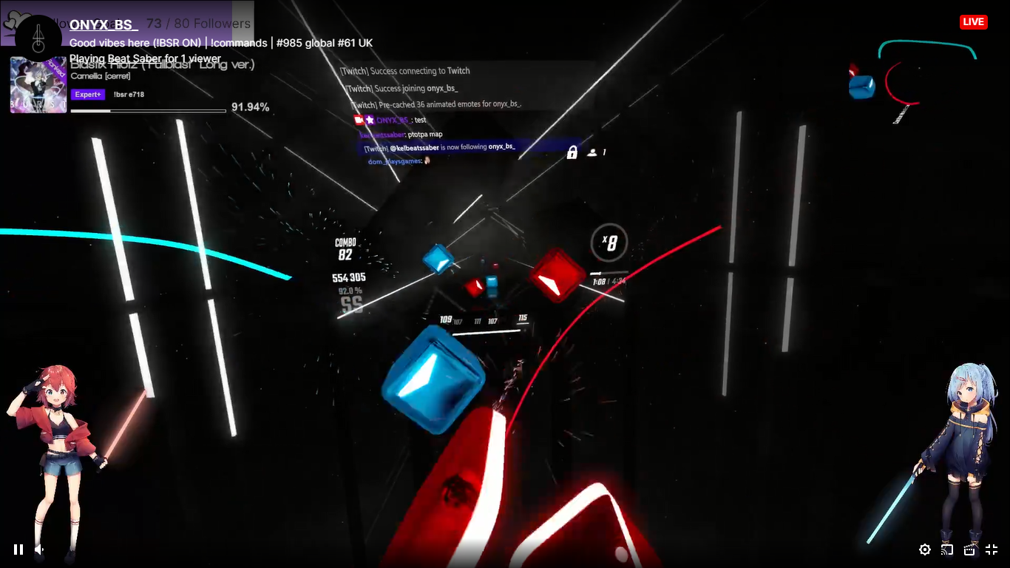

*Streaming VR games presents prospect of the streaming-integrated VR game platform*

The proposed system will increase the engagement between the streamers and their audiences. Unlike the chat message box, the application of VR allows the audiences to have their own persona and can communicate more naturally with the streamers. The content of streamers will be delivered to their audience just like in real life.

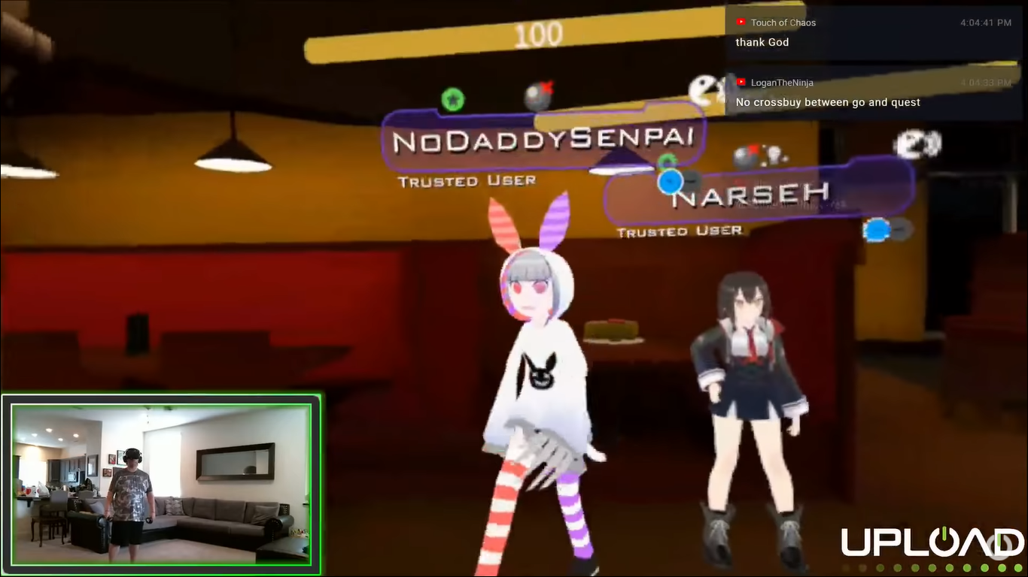

*Users’ interaction on VRChat gives a glimpse on the Metaverse*

# 6. Conclusion

The study focuses on the introduction of a new platform, which can make profits using both monetization methods from the game application and the streaming service. It has been accomplished by listing all the benefits for not just the game publisher, but also related entities like the streamers and the audiences and all the way for monetization methods. Because the system is the integration of both streaming and game, it inherits all the revenue streams from both of the services. This study also illustrates how the NFT works with the system, specifically, the NFT is the pushing factor, even enabling other new money making models. The NFT will make the services more profitable due to the fact that the system has dual purposes, meaning more chances of generating revenue. The future trends of the topic are also discussed including gamification and the metaverse. The potential of those game related topics is limitless, especially with the streaming integrated game system.

# References

CASCIATO, P., 2020. League of Legends Adds New Way for Sponsors to Advertise During Esports Matches.

Chohan, U. W., 2021. Non-Fungible Tokens: Blockchains, Scarcity, and Value.

Klepek, P., 2016. Twitch Chat Microtransactions Are Now A Thing.

Mehdi Kaytoue, Arlei Silva, Loïc Cerf, Wagner Meira Jr, 2012. Watch me playing, I am a professional: a first study on video game live streaming.

Miceli, M., 2021. *DOT ESPORT.* [Online]   
Available at: https://dotesports.com/streaming/news/full-list-of-all-twitch-payouts-twitch-leaks

Sherwin, N., 2019. Do Streaming Metrics on Twitch Affect Game Sales?.

Thier, D., 2016. *Twitch Has An Odd New Microtransaction System.* [Online]   
Available at: https://www.forbes.com/sites/davidthier/2016/06/28/twitchs-has-an-odd-new-microtransaction-system/?sh=780f03e774e7

Whitehead, T., 2022. *Talking Point: What Could NFTs Mean For Gaming, And Why Are They So Divisive?.* [Online]   
Available at: https://www.nintendolife.com/features/talking-point-what-could-nfts-mean-for-gaming-and-why-are-they-so-divisive